AAI written material (Kanchan Taksale)

## P1: What is Expert System

An expert system is a computer-based program designed to emulate the decision-making abilities of a human expert in a specific domain. It relies on a knowledge base, which contains a vast repository of information and rules, and an inference engine, which applies logical reasoning to draw conclusions and make decisions. Expert systems are a subset of artificial intelligence (AI) and are employed to solve complex problems and assist users in decision-making processes.

The knowledge base of an expert system is created by capturing the expertise of human specialists in a particular field, translating their knowledge into a format that the computer can understand. This knowledge is often represented in the form of rules, facts, and heuristics. The inference engine processes this information, utilizing logical reasoning and problem-solving techniques to provide solutions or recommendations.

Expert systems find applications in various domains, including medicine, finance, engineering, and troubleshooting. They excel at tasks that involve rule-based decision-making and can offer valuable insights, especially in situations where human experts may not be readily available. While expert systems have been successful in certain domains, advancements in machine learning and broader AI technologies continue to evolve, offering complementary approaches to problem-solving.

## P2: Design a Bot using AIML

AIML, or Artificial Intelligence Markup Language, is an XML-based language designed for creating chatbots and conversational agents. Developed in the late 1990s, AIML is specifically tailored for the development of interactive agents, allowing programmers to define patterns and responses in a straightforward manner. AIML serves as the brain behind many chatbots and virtual assistants, providing a structured way to encode knowledge and responses in a conversational format.

The process begins by identifying potential user inputs and crafting AIML patterns that match these inputs. The patterns can include wildcard characters and variables to make the bot's responses more flexible. Developers then create AIML templates that dictate the bot's replies based on the matched patterns.

AIML is particularly suitable for rule-based systems where the conversation follows a predefined path. It is efficient for tasks such as creating chatbots for specific domains like customer service or information retrieval.

However, it's essential to note that AIML has its limitations. It may struggle with handling complex and dynamic conversations, as it lacks the learning capabilities of more advanced natural language processing models. As technology has progressed, developers often combine AIML with other AI techniques, such as machine learning and NLP, to build more sophisticated and adaptive conversational agents.

## P3: Bayes Theorem

Bayes' Theorem, named after Reverend Thomas Bayes, is a fundamental concept in probability theory and statistics. The theorem provides a way to update the probability of a hypothesis based on new evidence or information. It's particularly useful in situations where we have prior knowledge about the probability of an event and want to adjust that probability based on additional data.

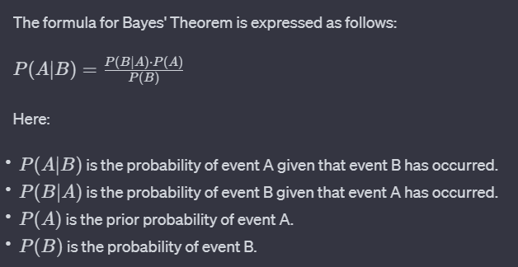

In words, Bayes' Theorem states that the probability of A given B is proportional to the probability of B given A, multiplied by the prior probability of A, and divided by the probability of B. It helps in updating beliefs about the likelihood of events as new information becomes available.

This theorem is widely used in various fields, including machine learning, statistics, and artificial intelligence. In Bayesian statistics, it plays a crucial role in updating probabilities as new data is observed. In machine learning, Bayesian methods are employed for tasks such as classification and spam filtering, where the algorithm needs to continually update its predictions based on new evidence.

## P4: Explain BFS and DFS

Breadth-First Search (BFS) and Depth-First Search (DFS) are two fundamental algorithms used for traversing and exploring graphs or tree structures. Breadth-First Search adopts a level-by-level approach, systematically visiting all neighbors of a node before moving on to the next level. It utilizes a queue data structure to keep track of nodes to be visited, ensuring that nodes at the current level are processed before moving deeper. BFS is particularly useful for tasks like finding the shortest path between two nodes or identifying connected components in a graph. While it guarantees the shortest path for unweighted graphs, it tends to require more memory and may face challenges with performance on large graphs.

On the other hand, Depth-First Search explores a graph by going as deep as possible along each branch before backtracking. It follows a more intuitive and recursive approach, visiting a node, exploring as far as possible along each branch, and backtracking only when necessary. DFS is implemented using a stack or recursion, making it memory-efficient and suitable for sparse graphs. It is often chosen for tasks like topological sorting, cycle detection, and solving problems with multiple solutions. However, DFS does not guarantee finding the shortest path, and there is a risk of getting stuck in infinite loops if not properly implemented. The choice between BFS and DFS depends on the specific requirements of the problem at hand and the characteristics of the data structure being explored.

## P5:Define Clauses, Facts, Predicates and Rules with Conjunction and Disjunction

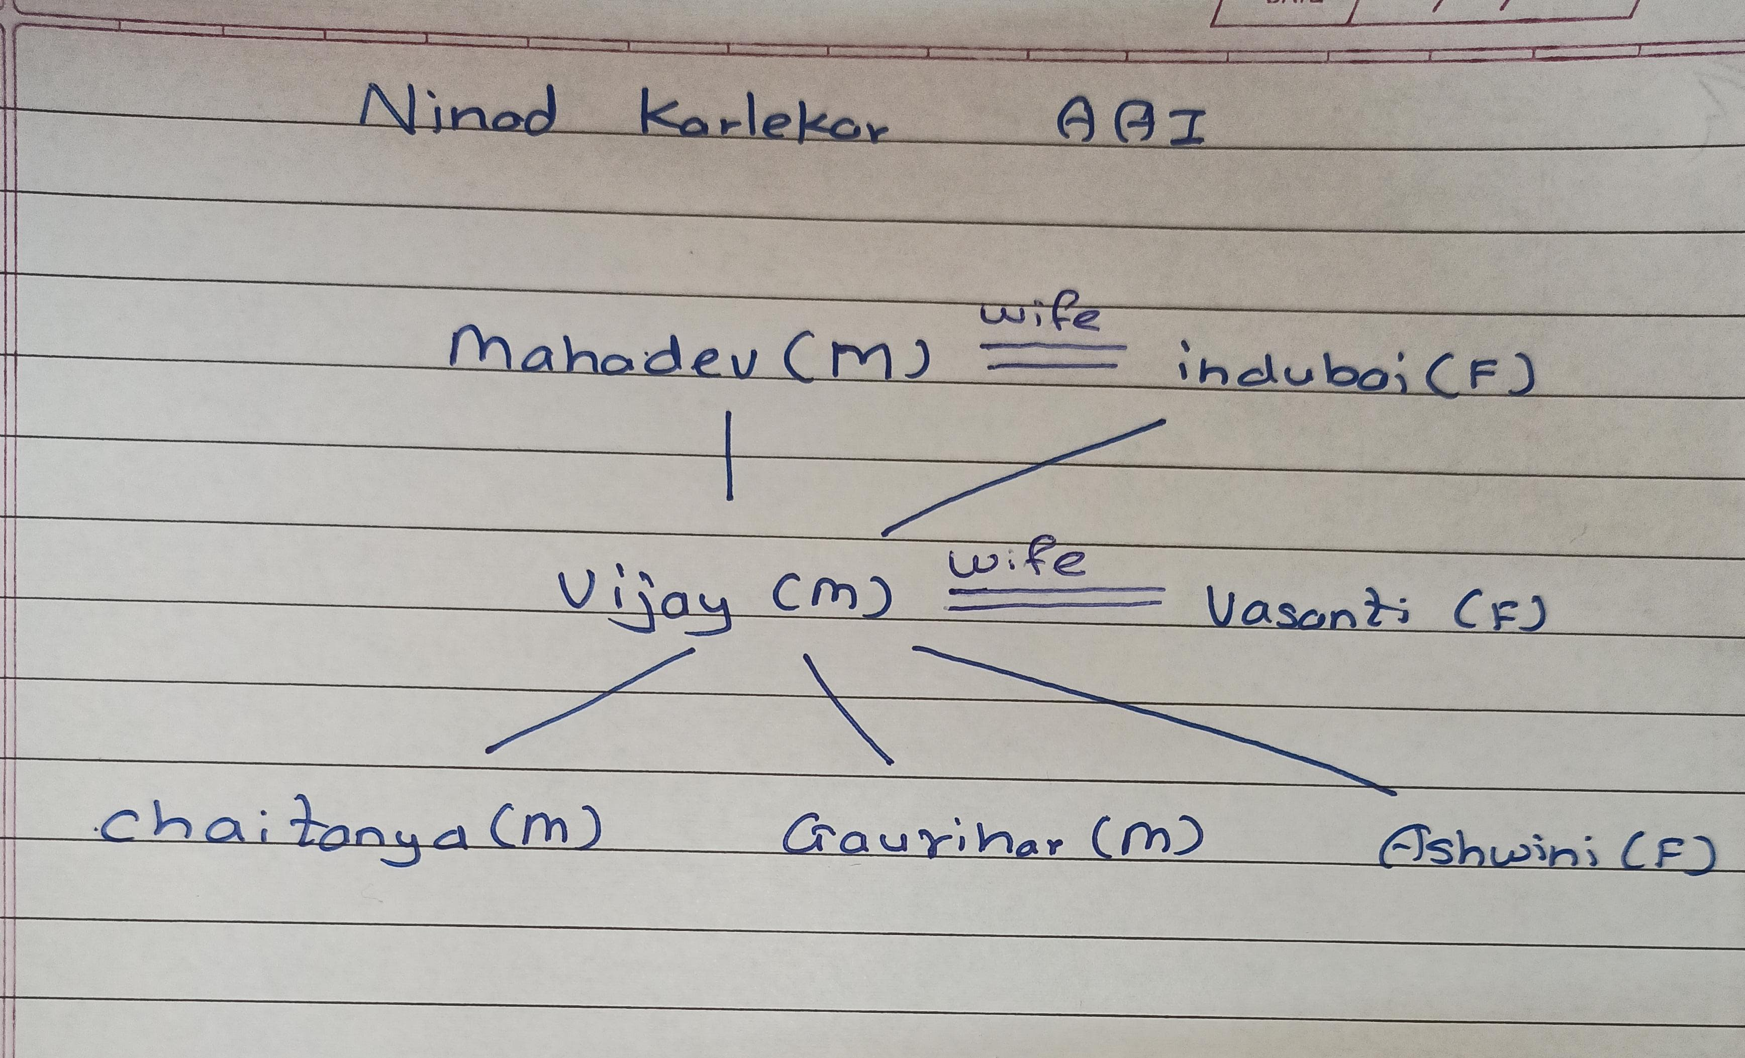

1. Clauses:

A clause is a syntactic unit of logic that expresses a proposition. It can be either a fact or a rule. Clauses are fundamental components in logic programming languages.

1. Facts:

A fact is a basic unit of knowledge that expresses a true statement. In terms of logic programming, a fact represents a simple assertion about the relationships or properties of objects. Facts are typically represented in the form of predicates.

1. Predicates:

A predicate is a logical expression that involves variables and constants. It represents a relationship between objects or a property of objects. Predicates are often used to form facts and rules. For example, in the statement "isBlue(Sky)," "isBlue" is a predicate.

1. Rules with Conjunction and Disjunction:

Rules: Rules are logical statements that define relationships or implications. They consist of a head and a body. The head specifies the conclusion or result, and the body contains conditions that must be satisfied for the rule to be true.

Conjunction: Conjunction is a logical operation that combines two or more conditions using the "AND" operator. In rules, conjunction is often used to express multiple conditions that must be true for the rule to be satisfied.

Disjunction: Disjunction is a logical operation that combines two or more conditions using the "OR" operator. In rules, disjunction allows for alternative conditions, stating that at least one of them must be true for the rule to hold.

## P6: What is Fuzzy Set? Operations on Fuzzy Set

What is Fuzzy Set ?

Fuzzy refers to something that is unclear or vague . Hence, Fuzzy Set is a Set where every key is associated with value, which is between 0 to 1 based on the certainty .This value is often called as degree of membership. Fuzzy Set is denoted with a Tilde Sign on top of the normal Set notation.

Operations on Fuzzy Set

1. Union : Consider 2 Fuzzy Sets denoted by A and B, then let’s consider Y be the Union of them, then for every member of A and B, Y will be:

degree_of_membership(Y)= max(degree_of_membership(A), degree_of_membership(B))

1. Intersection : Consider 2 Fuzzy Sets denoted by A and B, then let’s consider Y be the Intersection of them, then for every member of A and B, Y will be:

degree_of_membership(Y)= min(degree_of_membership(A), degree_of_membership(B))

1. Complement : Consider a Fuzzy Sets denoted by A , then let’s consider Y be the Complement of it, then for every member of A , Y will be:

degree_of_membership(Y)= 1 - degree_of_membership(A)

1. Difference : Consider 2 Fuzzy Sets denoted by A and B, then let’s consider Y be the Intersection of them, then for every member of A and B, Y will be:

degree_of_membership(Y)= min(degree_of_membership(A), 1-degree_of_membership(B))

## P7: Joint & Conditional Probability

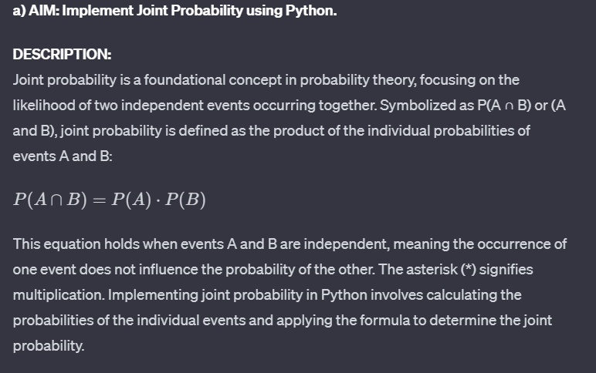

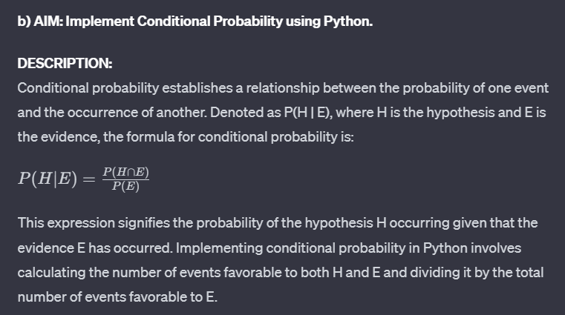

## P8: what is Clustering and What are types of Clustering

• Clustering:

Clustering is a machine learning technique that involves grouping similar data points together based on their inherent characteristics or features. It is used to discover patterns, associations, or structures within datasets, helping to identify natural groupings or clusters of data points, which can be valuable for tasks like customer segmentation, anomaly detection, and recommendation systems.

CLUSTERING:

Clustering Types: -

1. K-Means Clustering:

K-Means is one of the most popular clustering algorithms. It partitions data into K clusters based on the mean (center) of data points. It's effective for spherical clusters and works well when the number of clusters is known in advance.

1. Hierarchical Clustering

This approach creates a hierarchy of clusters by iteratively merging or splitting clusters. It can be

agglomerative (bottom-up) or divisive (top-down) and represents clusters in a tree-like structure

called a dendrogram.

1. DBSCAN (Density-Based Spatial Clustering of Applications with Noise)

DBSCAN groups together data points that are close to each other while considering density. It can

discover clusters of arbitrary shapes and is robust to noise.

1. Agglomerative Clustering:

This hierarchical clustering method starts with each data point as a separate cluster and then merges

them iteratively. It is intuitive and useful when the number of clusters is not predetermined.

## P9: Supervised & Unsupervised

**Supervised Learning:**

Supervised learning is a machine learning approach where the algorithm learns from labeled training data. The training dataset includes input-output pairs, and the algorithm's objective is to learn a mapping from the input to the output. During training, the algorithm receives feedback, allowing it to adjust its parameters for better performance. The primary goal of supervised learning is to create a model that can accurately predict the output for new, unseen data. This approach is widely used in applications such as image recognition, speech recognition, natural language processing, and solving regression problems.

**Unsupervised Learning:**

Unsupervised learning is a machine learning paradigm where the algorithm learns from unlabeled data. Unlike supervised learning, there are no explicit input-output pairs in the training dataset. The algorithm explores the inherent structure of the data, aiming to discover patterns, relationships, or clusters without guidance. Unsupervised learning models operate without explicit feedback during training, relying on the intrinsic patterns within the data. The primary goal of unsupervised learning is to uncover hidden structures, group similar data points, or reduce the dimensionality of the data. This approach finds applications in clustering, dimensionality reduction, anomaly detection, and generative modeling, addressing problems like customer segmentation, data visualization, and outlier detection.